Family Fun RV TRAVEL ASSURANCE

📋 GET A SERVICE CONTRACT QUOTE (BOTTOM OF PAGE)
When you're out on the road, the last thing you want to worry about are problems with your RV. Give yourself and your family the peace of mind that comes with having a reliable RV Travel Assurance Plan.
Trip Interruption expenses are also covered, including towing, rental car and hotel reimbursements. In the event that the unexpected happens, you don’t have to worry. Any covered repair has a $100 deductible, the warranty covers 100% parts and 100% labor and then you’re on your way again. This program is refundable in the event you sell or trade your RV as well as transferrable one time in the event you sell private party and wish to pass the benefits on to the next lucky owner!

THE Family Fun RV TRAVEL ASSURANCE PLAN CAN BE UTILIZED AT ANY CERTIFIED REPAIR FACILITY IN THE US OR CANADA AND COVERS THE MAJOR SYSTEMS OF THE COACH INCLUDING, BUT NOT LIMITED TO:

MOTORIZED COVERAGE

✔️CHASSIS 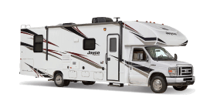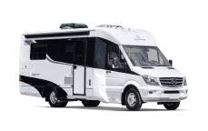

- ✔️ Engine

- ✔️ Transmission

- ✔️ Drive axle

- ✔️ Suspension

- ✔️ Steering

- ✔️ Dash Air Conditioning

- ✔️ Brakes

- ✔️ Electrical

- ✔️ Electronics

- ✔️ Heating & Cooling

- ✔️ Fuel Delivery

- ✔️ Chassis Frame

- ✔️ Seals & Gaskets

✔️HOUSE
- ✔️ Hot Water Heater

- ✔️ Waste System

- ✔️ Fresh Water System

- ✔️ House Air Condition

- ✔️ Range & Over

- ✔️ L.P. Gas System

- ✔️ Heating System

- ✔️ Refrigerator

- ✔️ Generator

- ✔️ Power Step

- ✔️ Electrical Systems

- ✔️ Audio Systems

- ✔️ Converter Battery Charger

- ✔️ Surge/Electrical Trailer Brakes

- ✔️ Ventilation & exhaust Fans

- ✔️ Awnings

- ✔️ Seals & Gaskets

- ✔️ Fuel/LP Gas Replacement

- ✔️ Audio Visual

- ✔️ Ultra-High Tech Electronic

- ✔️ Wheel Chair lift if applicable

- ✔️ Seals and Gaskets

- ✔️ Deluxe appliance

- ✔️ Hydraulic/Electric Leveling Jacks

- ✔️ Hydraulic/Electric Slide Out Rooms

- ✔️ Rental Car Reimbursement
(Up to 5 days @ $50/day)

- ✔️ Towing Reimbursement
(Up to $500 per occurrence)

- ✔️ Emergency Travel Expense
(Up to $600 / $200/day)

- ✔️ Service Calls if RV is immobile
FULL TRAVEL ASSURANCE PROGRAM DETAILS

TOWABLE COVERAGE

✔️TOWABLE 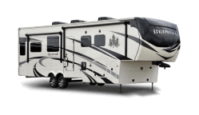 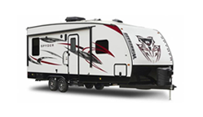
- ✔️ Hot Water Heater

- ✔️ Waste System

- ✔️ Fresh Water System

- ✔️ House Air Condition

- ✔️ Range & Over

- ✔️ L.P. Gas System

- ✔️ Heating System

- ✔️ Refrigerator

- ✔️ Generator

- ✔️ Power Step

- ✔️ Electrical Systems

- ✔️ Audio Systems

- ✔️ Converter Battery Charger

- ✔️ Surge/Electrical Trailer Brakes

- ✔️ Ventilation & exhaust Fans

- ✔️ Awnings

- ✔️ Seals & Gaskets

- ✔️ Service Calls if RV is immobile

- ✔️ Fuel/LP Gas Replacement

- ✔️ Audio Visual

- ✔️ Ultra-High Tech Electronic

- ✔️ Wheel Chair lift if applicable

- ✔️ Seals and Gaskets

- ✔️ Deluxe appliance

- ✔️ Hydraulic/Electric Leveling Jacks

- ✔️ Hydraulic/Electric Slide Out Rooms

- ✔️ Emergency Travel Expense
(Up to $600 / $200/day)

FULL TRAVEL ASSURANCE PROGRAM DETAILS

📋 GET A QUOTE - TRAVEL ASSURANCE PLAN

Name *
Email *
Phone *
Zip/Postal *
How can we help you?
It's ok to contact me about future discounts and events.(Easily unsubscribe at any time.)
* Required

